Plate Movement
Diagram | Type of plate boundary | Plate movement | Description of what is happening at the plate boundary | Hazards found | Example of plate movement
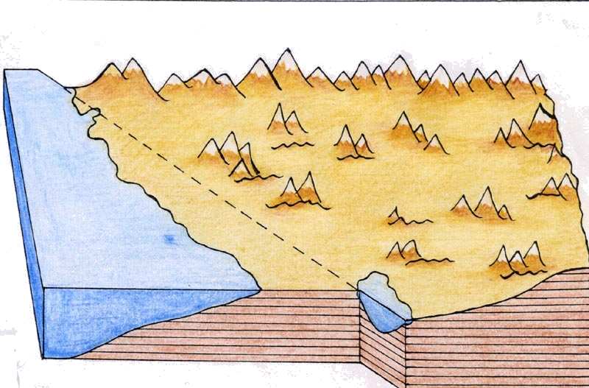 | Conservative plate boundary | Plates slide past each other | Plates slide past each other and lock. The pressure builds up and suddenly they snap loose. Shockwaves cause earthquakes on the surface | Earthquakes | Pacific Plate and North American Plate
